21CSP109L - PROJECT

CLOUD COMPILER: A DISTRIBUTED WEB-BASED CODE EXECUTION AND ANALYSIS PLATFORM
A PROJECT REPORT
Submitted by
ULLAS DEWANGAN – RA2311003050094

Under the guidance of
DR. JOSEPHINE USHA L
(Assistant Professor, Department of Computer Science & Engineering)
in partial fulfillment of the requirements for the
degree of
BACHELOR OF TECHNOLOGY
in

COMPUTER SCIENCE AND ENGINEERING

DEPARTMENT OF COMPUTER SCIENCE AND ENGINEERING
FACULTY OF ENGINEERING AND TECHNOLOGY
SRM INSTITUTE OF SCIENCE AND TECHNOLOGY
TIRUCHIRAPPALLI, TAMIL NADU - 621105
MARCH 2026

DECLARATION
I hereby declare that the project report entitled "Cloud Compiler: A Distributed Web-Based Code Execution and Analysis Platform" submitted in partial fulfillment of the requirements for the award of the degree stated on the title page is my original work. The report has been prepared from the design, implementation, and analysis of the software system present in the Cloud Compiler project workspace. The work described here has not been submitted, in whole or in part, to any other university or institution for the award of any degree, diploma, or similar academic recognition.
Place: SRM Institute of Science & Technology, Tiruchirappalli
Date: 25th March 2026

ULLAS DEWANGAN [RA2311003050094]

BONAFIDE CERTIFICATE
(Under Section 3 of UGC Act, 1956)

Certified that this project report titled "Cloud Compiler: A Distributed Web-Based Code Execution and Analysis Platform" is the Bonafide work of Ullas Dewangan [RA2311003050094] , who carried out the project work under my supervision. To the best of my knowledge, the work reported herein does not form part of any other project report or dissertation on the basis of which a degree or award was conferred earlier on this or any other candidate.

SIGNATURE | SIGNATURE
DR. JOSEPHINE USHA L  SUPERVISOR  Assistant Professor  Dept. of Computer Science & Engineering  SRM Institute of Science and Technology - Tiruchirappalli | DR. S. KANAGA SUBA RAJA  HEAD OF THE DEPARTMENT  Professor & Head  Dept. of Computer Science & Engineering  SRM Institute of Science and Technology - Tiruchirappalli
Submitted for the End Semester Project Viva - voce held on
Signature of Internal Examiner | Signature of External Examiner

ACKNOWLEDGEMENTS
We would like to express my deepest gratitude to the entire management of SRM Institute of Science and Technology for providing me with the necessary facilities for the completion of this project.
I wish to express my deep sense of gratitude and sincere thanks to our Professor & Dean Dr. Jagadeesh Kannan ME., Ph.D., D.Sc., EPGC for his encouragement, timely help, and advice offered to me.
I wish to express my deep sense of gratitude and sincere thanks to our Professor & Associate Dean (SoC) of the Department Dr. S. Kanaga Suba Raja ME., Ph.D for his encouragement, timely help, and advice offered to me.
I am very grateful to my guide Dr. Josephine Usha L ME., Ph.D Assistant Professor, Department of Computer Science and Engineering, who has guided me with inspiring dedication, untiring efforts, and tremendous enthusiasm in making this project successful and presentable.
I would like to express my sincere thanks to the project coordinator Dr. Josephine Usha L ME., Ph.D and panel member Dr. V. Mani for their time and suggestions for the implementation of this project.
I also extend my gratitude and heartful thanks to all the teaching and non-teaching staff of the Department of Computer Science & Engineering and to my parents and friends, who extended their kind cooperation using valuable suggestions and timely help during this project work.

ABSTRACT
Cloud Compiler is a distributed web platform that allows users to write code in the browser, choose a programming language, provide input, and obtain execution results without requiring a local compiler toolchain. The system combines a React and TypeScript frontend, a FastAPI backend, Redis-based asynchronous job handling, a Python worker service, Docker-based sandboxed execution, PostgreSQL-backed authentication, and monitoring endpoints for runtime visibility. The goal of the project is to transform code execution from a local, machine-specific activity into a managed service that is accessible, observable, and safer to operate.

TABLE OF CONTENTS
CLOUD COMPILER: A DISTRIBUTED WEB-BASED CODE EXECUTION AND ANALYSIS PLATFORM 1
DECLARATION 2
BONAFIDE CERTIFICATE 3
ACKNOWLEDGEMENTS 4
ABSTRACT 5
TABLE OF CONTENTS 6
LIST OF TABLES 9
LIST OF FIGURES 9
ABBREVIATIONS 9
CHAPTER 1 11
INTRODUCTION 11
INTRODUCTION 11
PROBLEM STATEMENT 11
OBJECTIVE 12
SPECIFIC OBJECTIVES 12
SCOPE 12
INNOVATION 13
CHAPTER 2 14
LITERATURE SURVEY 14
OVERVIEW 14
CHAPTER 3 15
PROPOSED WORK 15
GENERAL INTRODUCTION TO CLOUD COMPILER 15
DESIGN OF CLOUD COMPILER 16
EXPERIMENTAL STUDY 17
PERFORMANCE METRICS 18
CHAPTER 4 20
SYSTEM ARCHITECTURE AND IMPLEMENTATION 20
OVERVIEW 20
SYSTEM ARCHITECTURE 20
AUTHENTICATION AND ACCESS CONTROL 22
WORKSPACE IMPLEMENTATION 23
MONITORING AND VISUALIZATION 24
SYSTEM FLOW 24
TECHNOLOGY STACK 25
END-TO-END EXECUTION LIFECYCLE 26
CHAPTER 5 28
RESULTS AND DISCUSSION 28
EXPERIMENTAL RESULT ANALYSIS 28
FUNCTIONAL PERFORMANCE 29
OUTPUTS AND USER-FACING MODULES 30
CHAPTER 6 32
CONCLUSION AND FUTURE ENHANCEMENT 32
CONCLUSION 32
FUTURE ENHANCEMENT 32
REFERENCES 34
APPENDIX I 35
A1. USER INTERFACE MODULES 35
A2. API ENDPOINT SUMMARY 35
APPENDIX II 37
A3. USER TABLE SCHEMA 37
A4. SAMPLE REQUEST AND RESPONSE PAYLOADS 37

LIST OF TABLES
Table 1: Summary of Literature Insights
Table 2: Comparative Study of Existing Execution Approaches
Table 3: Functional Requirements and Design Mapping
Table 4: Test Environment
Table 5: Performance Metrics Used for Evaluation
Table 6: Component Implementation Details
Table 7: Technology Stack of the Project
Table 8: Build and Static Verification Results
Table 9: Functional Validation Matrix
Table 10: Future Enhancement Roadmap

LIST OF FIGURES
Figure 1: High-Level Cloud Compiler Architecture
Figure 2: Asynchronous Execution Sequence Flow
Figure 3: Authentication and Protected Route Flow
Figure 4: Workspace Interaction Model
Figure 5: Monitoring and Visualization Pipeline
Figure 6: End-to-End Execution Lifecycle

ABBREVIATIONS
Abbreviations Used in the Report
Abbreviation | Expansion
API | Application Programming Interface
ASGI | Asynchronous Server Gateway Interface
CPU | Central Processing Unit
CORS | Cross-Origin Resource Sharing
IDE | Integrated Development Environment
JSON | JavaScript Object Notation
JWT | JSON Web Token
RBAC | Role-Based Access Control
REST | Representational State Transfer
UI | User Interface
UX | User Experience
URL | Uniform Resource Locator

CHAPTER 1

INTRODUCTION

INTRODUCTION
The modern software development workflow increasingly depends on tools that can be accessed from anywhere, on any operating system, with minimal setup overhead. In classrooms, laboratories, coding assessments, and lightweight prototyping environments, local installation problems still act as a barrier: students may lack compatible compilers, different machines may produce different behaviors, and faculty or administrators may find it difficult to standardize the execution environment across a batch of users. Cloud Compiler addresses this problem by presenting programming as a web service rather than as a locally provisioned toolchain.
The project provides a browser-first interface where users can authenticate, write programs, supply standard input, run code, inspect output, export files, and review execution history. Behind this user-facing simplicity lies a distributed execution workflow. The frontend is responsible for interaction quality, but the backend and worker services coordinate execution, isolate untrusted code within Docker containers, and expose metrics that make the system transparent to administrators. This combination is valuable because a cloud compiler is not merely an editor with a run button; it is an operational platform that must balance usability, responsiveness, and risk containment.
Another important aspect of the project is the separation between immediate execution and queued execution. The synchronous path supports quick feedback and helps in local or low-volume use cases. The asynchronous path, backed by Redis and a dedicated worker, makes it possible to absorb spikes in demand and preserve API responsiveness. The design therefore mirrors patterns used in production systems, where latency-sensitive interfaces delegate expensive processing to background workers. This makes the project relevant not only as a student application but also as a compact demonstration of modern service-oriented system design.

PROBLEM STATEMENT
Existing code execution workflows in academic and small-team environments often suffer from one or more of the following limitations: heavy local setup requirements, inconsistent compiler versions, lack of sandboxing for untrusted code, poor visibility into queued work, and insufficient support for operational monitoring. Traditional local IDEs solve the coding problem but not the administration problem; online editors may offer convenience but do not always expose execution transparency, role-aware access control, or clear extensibility toward scaling. There is therefore a need for a platform that unifies browser-based coding, isolated multi-language execution, input and output handling, authentication, and runtime observability in a single manageable system.

OBJECTIVE
The main objective of the Cloud Compiler project is to build a reliable, web-accessible, and modular platform that allows users to compile and execute code remotely while preserving isolation, responsiveness, and administrative visibility. The project seeks to demonstrate that a compact distributed architecture can provide a meaningful alternative to local execution for learning, testing, and lightweight development workflows.

SPECIFIC OBJECTIVES
- To design a responsive browser-based workspace using React, TypeScript, and the Monaco editor for multi-language code authoring.
- To implement secure user registration and login using PostgreSQL-backed user data, password hashing, and JWT-based session tokens.
- To support Python, C, C++, and Java execution through Docker containers with CPU, memory, process, and network restrictions.
- To provide both synchronous and asynchronous execution pathways so that the interface remains usable under different load conditions.
- To maintain a Redis-backed worker registry and job history that can be exposed through metrics and visualization endpoints.
- To add practical utility features such as file import, text export, PDF export, stdin handling, and static complexity estimation.
- To establish an architecture that can be scaled later through worker orchestration and Kubernetes integration hooks.

SCOPE
The current scope of the project includes the complete application flow required for a working cloud compilation platform: authentication, protected routes, a code editor, execution APIs, worker-side job consumption, result retrieval, monitoring endpoints, and an administrative dashboard. The project is intentionally designed as a full-stack application rather than a single demo endpoint, because a report-worthy compiler service must include both the user experience and the system operations perspective.
The scope also covers selected non-functional requirements such as security boundaries, code text sanitization, execution timeout handling, and resource limits. At the same time, some production-grade capabilities remain outside the present implementation boundary. These include distributed result persistence across multiple database tables, advanced role management interfaces, language-specific static analysis beyond heuristic complexity estimation, and autoscaling logic fully wired to a live Kubernetes deployment. Those items are treated as future extensions rather than omitted concerns.

INNOVATION
The innovation in this project lies in how several practical software engineering ideas are composed into one coherent system. The application does not stop at browser-based code editing; it pairs that interface with queue-aware execution, container isolation, runtime metrics, and visualization support. This gives the project a stronger systems dimension than a standard online compiler assignment.
- Dual execution model: the system offers immediate synchronous execution for fast feedback and a queued asynchronous path for scalable workloads.
- Operational visibility: active workers, queue depth, job outcomes, and host resource metrics are exposed through dedicated endpoints and UI dashboards.
- Input sanitation on both frontend and backend: hidden Unicode spacing and zero-width characters are normalized before execution, reducing copy-paste related runtime surprises.
- Built-in complexity estimation: the workspace includes a lightweight static analyzer that estimates time and space complexity for supported languages.
- Autoscaling readiness: the backend launches an autoscaler loop and includes Kubernetes deployment hooks, showing a clear path from local use to orchestrated execution pools.

CHAPTER 2

LITERATURE SURVEY

OVERVIEW
The design of a cloud compiler sits at the intersection of several technical domains: web user interfaces, browser-based code editing, API-centric backend services, secure execution of untrusted programs, asynchronous messaging, and operational monitoring. No single framework solves all of these concerns. A useful literature survey for this project therefore examines both existing execution models and the enabling technologies that make the final system practical. In that sense, the survey functions as a design review of available approaches rather than only a catalog of finished products.

CHAPTER 3

PROPOSED WORK

GENERAL INTRODUCTION TO CLOUD COMPILER
The proposed system is a layered cloud compilation platform composed of a browser-based user interface, an API service, a queue layer, an execution worker, and supporting data stores. The design goal is to allow users to submit source programs without worrying about local compiler installation, while ensuring that execution remains controlled and observable. The final application exposes a workspace for coding, a backend for request orchestration, and a worker process that translates queued jobs into isolated Docker executions.
Development was approached incrementally. Authentication and routing formed the first layer because controlled access is essential even in academic environments. The second phase focused on the editor, execution endpoints, and Docker-based language runners. The third phase introduced background job submission, worker registration, metrics, and dashboards. The final phase refined usability through import and export features, output history, PDF generation, code text sanitization, and a static complexity analyzer. This progression kept the system testable at each stage and reduced integration risk.
Table 3: Functional Requirements and Design Mapping
Requirement | Implementation Decision | Project Module
User authentication | JWT-based login and protected routes | auth_routes.py, auth_utils.py, AuthContext.tsx
Write and edit code | Monaco-based browser editor | CodeEditor.tsx, Workspace.tsx
Run code instantly | Direct backend-to-Docker execution path | execution_routes.py, docker_manager.py
Run code asynchronously | Redis queue and worker consumer | queue_sender.py, worker.py
Track system state | Metrics and visualization routes | metrics_collector.py, metrics_routes.py, visualization_routes.py
Support multi-language use | Language-specific runner mapping | DockerManager.LANGUAGE_CONFIG, worker execute_code
Preserve usability | History, stdin, file import/export, PDF export | Workspace.tsx, OutputPanel.tsx

DESIGN OF CLOUD COMPILER
At the design level, Cloud Compiler is organized into presentation, application, execution, data, and operations layers. The presentation layer is the React application. It manages routing, authentication state, editor interaction, and API invocation. The application layer is implemented through FastAPI, which receives requests, validates payloads, applies text sanitization, and chooses between synchronous and asynchronous execution paths. The execution layer is split between a direct Docker manager and a dedicated worker process for queued jobs. The data layer includes PostgreSQL for user accounts and Redis for jobs, results, and worker heartbeat information. The operations layer includes metrics, dashboards, and autoscaling hooks.
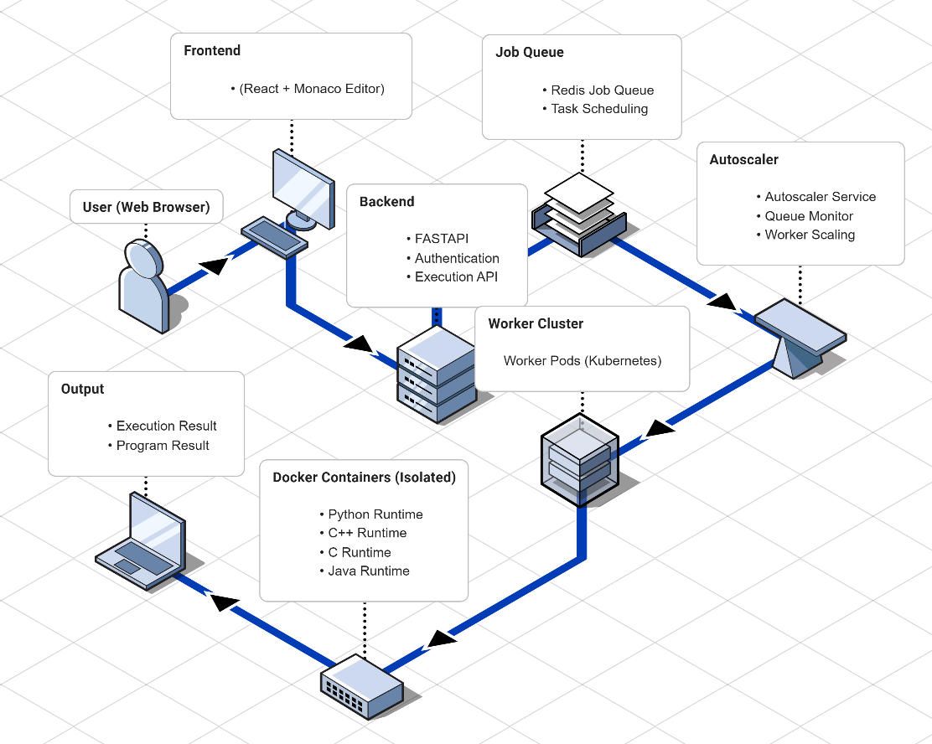
Figure 1: High-Level Cloud Compiler Architecture

The architecture uses two execution paths so that quick runs and queue-backed runs can co-exist within one interface.

EXPERIMENTAL STUDY
The evaluation approach for this project combines implementation verification, build validation, and workflow analysis. Because the full end-to-end system depends on Docker, Redis, and PostgreSQL services running together, the report distinguishes between static readiness and runtime deployment validation. Static readiness asks whether modules compile, routes are wired, assets build, and core algorithms behave as expected. Runtime deployment validation concerns how these verified modules behave when all external services are active.
Table 4: Test Environment
Item | Configuration / Observation
Operating environment | Windows workstation with PowerShell-based project workspace
Backend runtime | Python virtual environment with FastAPI-oriented dependencies
Frontend runtime | Node.js / Vite build pipeline with installed node_modules
Queue / cache | Redis expected on localhost:6379
Execution isolation | Docker Desktop and per-language runner images
Persistence | PostgreSQL configured through backend/database.py
Verification commands | Python compileall, Vite production build, targeted module checks

PERFORMANCE METRICS
Table 5: Performance Metrics Used for Evaluation
Metric | Meaning | How it is used in this report
Build success | Whether frontend assets compile for production | Used to validate deployability of the client application
Module compilation | Whether backend and worker Python files parse correctly | Used as static correctness evidence
Execution pathway availability | Whether sync and async paths are implemented end-to-end in code | Used in the functional validation matrix
Queue depth visibility | Availability of queue length metrics | Used to assess operational observability
Worker visibility | Availability of worker registry and status | Used to assess distributed execution traceability
Result availability | Mechanism to retrieve completed output | Used to confirm the async job lifecycle
Bundle size warning | Whether the frontend emits optimization warnings | Used as an honest indicator of future performance work

CHAPTER 4

SYSTEM ARCHITECTURE AND IMPLEMENTATION

OVERVIEW
The Cloud Compiler implementation is intentionally modular. Each major responsibility is assigned to a dedicated file or component set: authentication logic, execution routing, queue submission, worker-side execution, monitoring, visualization, frontend pages, and UI widgets. This structure makes the codebase readable and keeps the project extensible. The backend remains relatively thin at the API layer because complex work is delegated either to helper modules or to the worker process.

SYSTEM ARCHITECTURE
Figure 2: Asynchronous Execution Sequence Flow

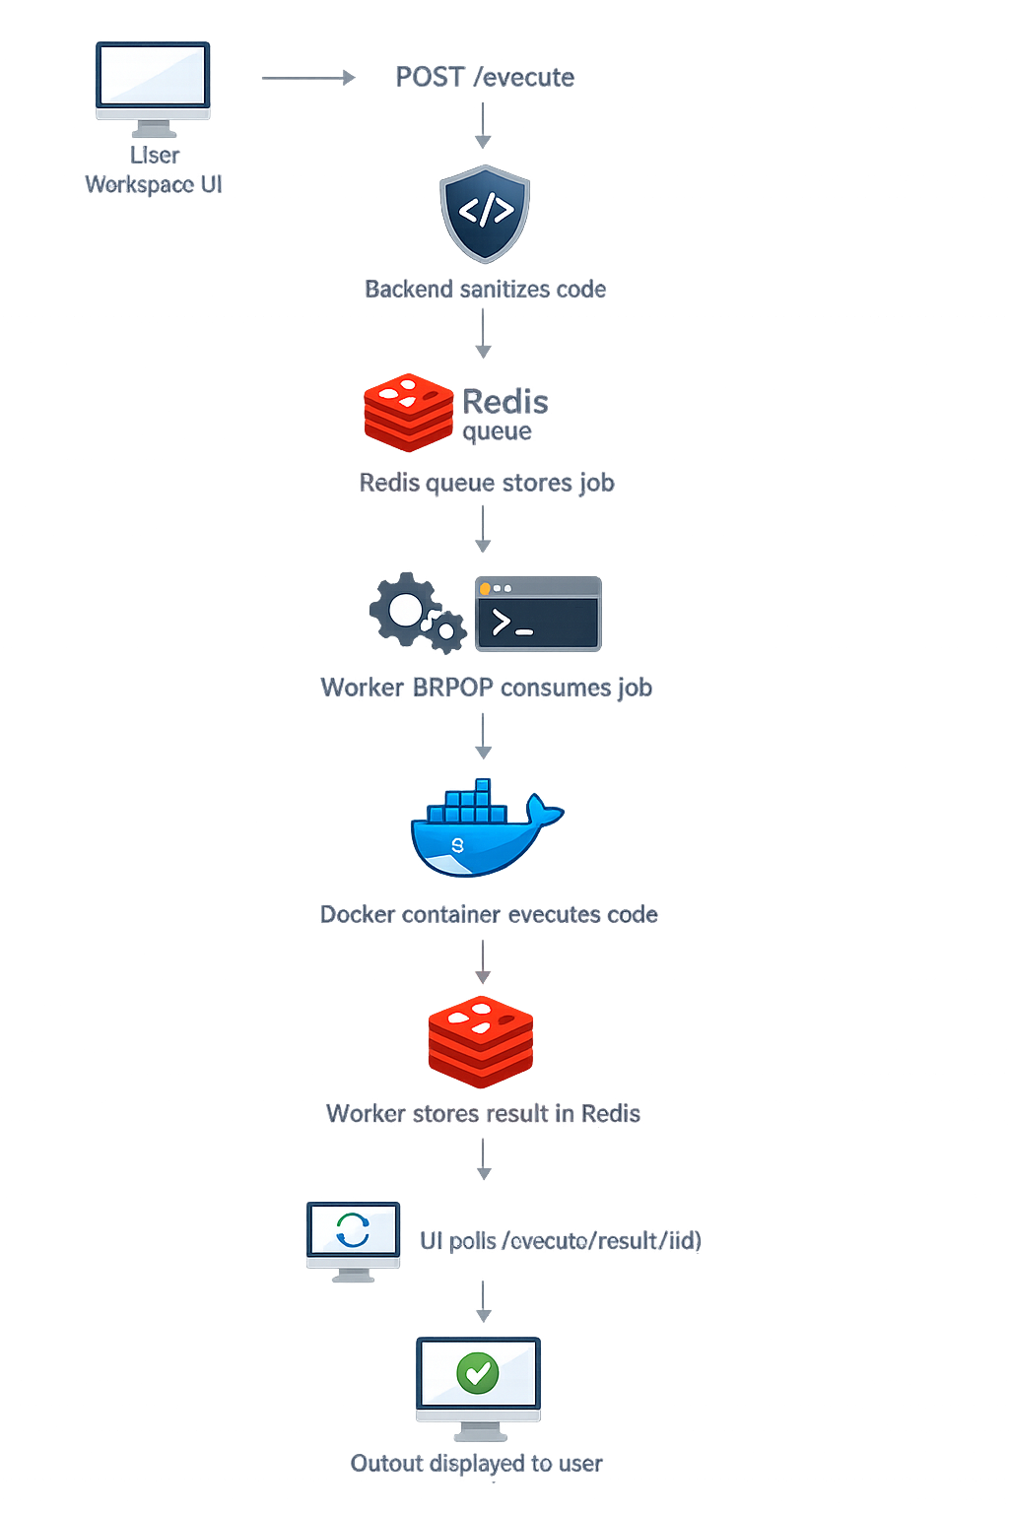
The asynchronous path keeps the request-response cycle lightweight while a worker handles execution in the background.


The frontend uses React Router to separate login, registration, workspace, metrics, and dashboard views. Protected routes are enforced through the authentication context, which stores the JWT access token in local storage and adds it to subsequent API requests. The workspace page manages language selection, code, stdin, export naming, complexity results, output state, and local execution history. This gives the user a coherent workstation-like experience even though the actual code execution takes place remotely.
The backend centers around FastAPI route groups. Authentication routes create and validate users. Execution routes expose complexity analysis, synchronous execution, asynchronous submission, result lookup, file import, and file export. Metrics routes expose queue, worker, system, and job summaries to authorized admins. Visualization routes aggregate system state into a dashboard-friendly response. The backend also starts an autoscaler thread during application lifespan startup, demonstrating the intended control loop for worker scaling.
Table 6: Component Implementation Details
Component | Implementation Detail | Role in the System
Auth routes | Register and login endpoints using SQLAlchemy session access | Creates users and issues JWT tokens
Auth utilities | bcrypt hashing with SHA-256 pre-hash plus JWT creation | Protects passwords and signs tokens
Execution routes | Sync, async, result, import/export, complexity endpoints | Acts as the main orchestration layer
Docker manager | Temporary directory + docker run + timeouts | Executes synchronous jobs in isolated containers
Queue sender | Redis LPUSH with generated job_id | Moves async work out of the request thread
Worker service | BRPOP consumer with registry heartbeat updates | Executes queued jobs and records results
Metrics collector | Reads Redis state and psutil host metrics | Supports monitoring and admin views
Visualization routes | Aggregates recent executions and system summaries | Feeds dashboard-style pages

AUTHENTICATION AND ACCESS CONTROL
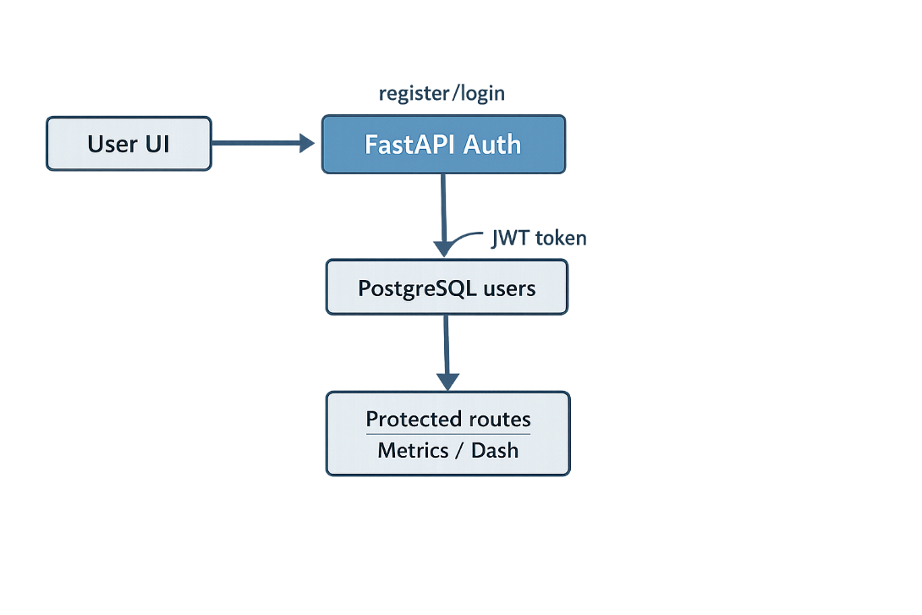
Figure 3: Authentication and Protected Route Flow
Only authenticated users enter the workspace; admin-only routes add one more authorization layer using the role claim and database lookup.
Password handling is implemented carefully. Before bcrypt hashing, the password is pre-hashed with SHA-256 so that bcrypt's 72-byte input limitation does not cause truncation issues. The verification path preserves backward compatibility for previously stored hashes. The JWT payload carries both the subject and role, allowing the backend to restrict metrics and dashboard endpoints through a dedicated require_admin dependency. Although the secret key is currently hardcoded and should be externalized for production, the overall authentication structure is sound for the current project stage.

WORKSPACE IMPLEMENTATION
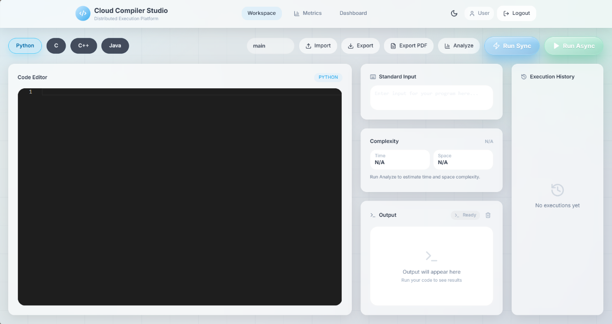
Figure 4: Workspace Interaction Model

The workspace consolidates authoring, execution, analysis, and review into one interaction surface.
The workspace is the most feature-rich page in the frontend. It coordinates language selection, code sanitization, async polling, sync execution, import and export operations, toasts, and history playback. Each major function is encapsulated in a dedicated component: CodeEditor for Monaco integration, Output Panel for execution status and logs, Stdin Input for user-provided input, and Execution History for quick recall of recent runs. This component decomposition keeps the page large in capability but manageable in structure.
A notable usability feature is text sanitization on both frontend and backend. Hidden spaces, zero-width characters, and box glyphs are normalized before execution. This is a practical design choice because pasted code often contains invisible characters that cause frustrating runtime or syntax errors. By cleaning text on both sides, the system reduces the chance that a malformed clipboard event becomes a hard-to-diagnose bug for the user.

MONITORING AND VISUALIZATION
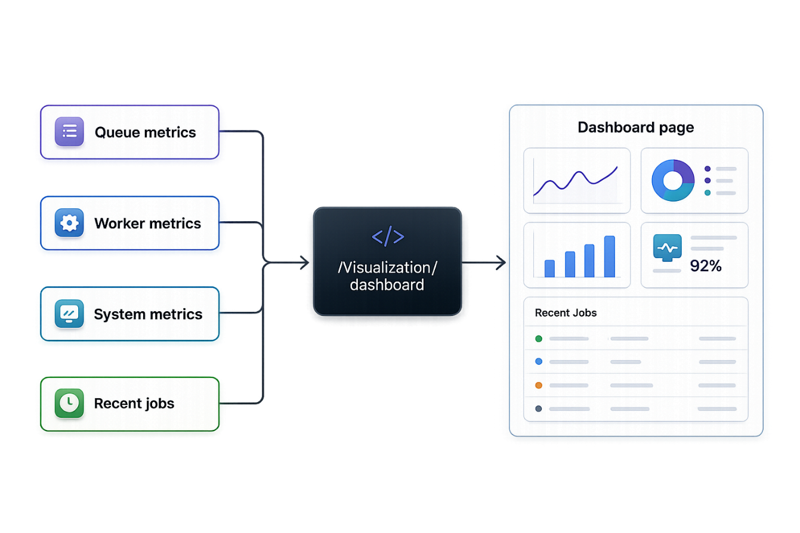
Figure 5: Monitoring and Visualization Pipeline

Monitoring data is aggregated server-side so the dashboard can render one coherent system view.
The monitoring subsystem is intentionally simple but meaningful. Queue metrics expose current backlog. Worker metrics expose active workers and the jobs they are processing. System metrics expose host CPU and memory usage through psutil. Job metrics estimate completed and failed runs by scanning recent execution history. The dashboard route aggregates these into a single response that the frontend converts into cards, worker status lists, and charts. This design choice reduces client complexity and centralizes the monitoring contract.

SYSTEM FLOW
- A user logs in through the frontend and receives a JWT access token.
- The user opens the workspace, selects a language, enters code, and optionally provides stdin.
- Before submission, the frontend sanitizes the editor text and input text.
- For synchronous runs, the backend creates a temporary execution directory and invokes Docker directly.
- For asynchronous runs, the backend sanitizes the payload, generates a job ID, and pushes the job into the Redis queue.
- The worker process blocks on BRPOP, retrieves the job, updates its registry state, and maps the request to the correct runner image.
- The worker mounts the current working directory inside the container, executes the compile or run command, and captures stdout or stderr.
- The result is stored in Redis using the job ID as the lookup key, and the worker returns to idle state.
- The frontend polls the result endpoint, updates the output panel, and stores the execution snapshot in local history.
- Admins can inspect queue status, worker state, system load, and recent jobs through the metrics and dashboard pages.

TECHNOLOGY STACK
Table 7: Technology Stack of the Project
Layer | Technology | Reason for Selection
Frontend | React 18 + TypeScript + Vite | Fast developer workflow, component model, typed client logic
Editor | Monaco Editor | Rich browser-based code editing and syntax support
Styling | Tailwind-inspired utility styling + custom theme CSS | Rapid UI composition with a distinct visual style
Backend | FastAPI | Clear route definition, modern Python typing, simple dependency injection
Authentication | JWT + bcrypt + OAuth2-compatible flow | Stateless access control with secure password hashing
Queue / cache | Redis | Lightweight job buffering and result storage
Worker | Python worker service | Simple integration with Redis and Docker SDK
Isolation | Docker | Resource-limited multi-language execution environment
Persistence | PostgreSQL + SQLAlchemy | Reliable relational storage for users and roles
Operations | psutil, dashboard routes, autoscaler hooks | Runtime visibility and scale-readiness

END-TO-END EXECUTION LIFECYCLE
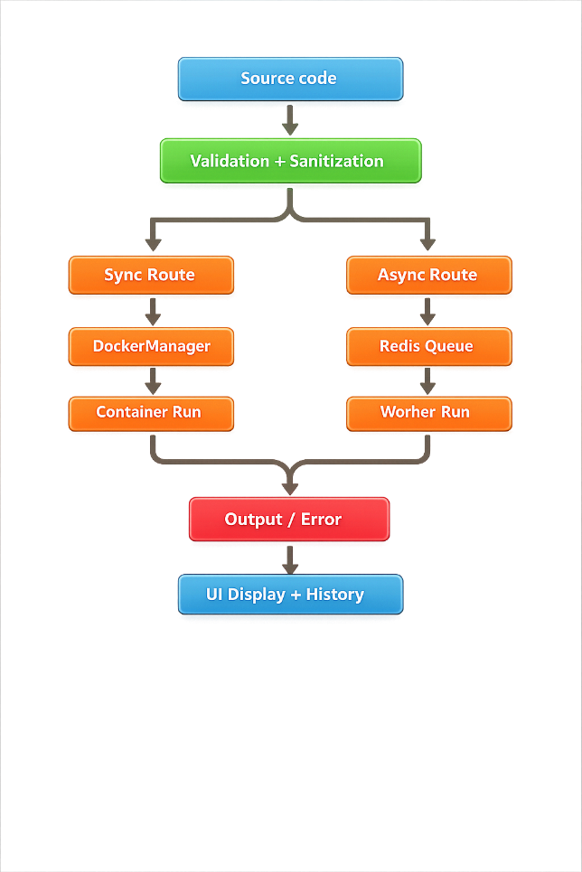
Figure 6: End-to-End Execution Lifecycle

Both execution paths converge on the same user-facing output model, preserving a consistent interface.

CHAPTER 5

RESULTS AND DISCUSSION

EXPERIMENTAL RESULT ANALYSIS
The results for this project should be interpreted in the context of a full-stack system whose behavior depends partly on local services such as Docker, Redis, and PostgreSQL. For that reason, the evaluation in this report prioritizes evidence that was directly observed in the current workspace and separates it from environment-dependent runtime outcomes. Static readiness checks confirm whether the codebase builds and whether important modules parse correctly. Functional analysis confirms whether the implementation pathways exist and are coherently wired. Together, these observations provide a credible picture of project maturity without claiming benchmark data that was not collected.
Table 8: Build and Static Verification Results
Check | Observed Result | Interpretation
Python backend / worker compilation | Successful through compileall | Core Python modules are syntactically valid in the workspace
Frontend production build | Successful via Vite build | Client application can be bundled for deployment
Frontend bundle analysis | Large JS chunk warning at 768.47 kB | Application works, but code-splitting should be improved
Complexity analyzer sample | Returned O(n) time and O(1) space for a simple Python loop | Static analysis endpoint is functionally active
Auth, metrics, dashboard routes | Present and connected through router configuration | Administrative capabilities are integrated at the API level

The verification commands were executed in the project workspace on March 25, 2026.

FUNCTIONAL PERFORMANCE
Table 9: Functional Validation Matrix
Feature | Status | Evidence / Discussion
User registration | Implemented | FastAPI route checks username uniqueness and stores user in PostgreSQL-backed model.
User login | Implemented | OAuth2 password flow issues bearer JWT tokens with role claim.
Protected workspace access | Implemented | React ProtectedRoute relies on stored access token.
Synchronous execution | Implemented | DockerManager runs language-specific commands inside temporary containerized workspaces.
Asynchronous execution | Implemented | Backend pushes jobs into Redis and worker consumes them with BRPOP.
Result polling | Implemented | Frontend polls result endpoint until job completion.
Complexity analysis | Implemented and sampled | Backend performs heuristic static complexity estimation for four languages.
File import and export | Implemented | Source code import, text export, and PDF export are available from the workspace.
Metrics dashboard | Implemented | Queue, worker, system, and job metrics feed dedicated monitoring pages.
Autoscaling extension point | Partially integrated | Autoscaler loop and Kubernetes scaling hook exist but require live infrastructure.

The most visible strength of the system is the way user experience and operational design are tied together. The user receives a polished workspace with modern controls, but the backend simultaneously tracks worker health and queue depth. This is important because educational compiler platforms often focus exclusively on the front of the application and neglect the service behavior that becomes critical as more users submit jobs.
The presence of both synchronous and asynchronous execution modes is another strong design result. Short programs benefit from immediate execution, whereas high-concurrency or slower-running programs benefit from queue decoupling. The implementation therefore scales in architectural sophistication without forcing the user to learn different workflows. On the same screen, the user simply chooses Run Sync or Run Async, while the system internally selects the appropriate path.
The results also reveal improvement areas. The frontend build completed successfully, but Vite reported a JavaScript chunk larger than 500 kB after minification. This indicates that the UI, especially with Monaco and charting dependencies, would benefit from route-level or component-level code splitting. In addition, some backend configuration values such as the secret key and database URL are hardcoded. These choices are acceptable during development but should be externalized before deployment in a shared environment.

OUTPUTS AND USER-FACING MODULES
- Login and registration modules provide token-based access control with modern form design and validation feedback.
- The workspace offers language switching, code editing, input entry, output display, complexity reporting, and local execution history.
- The metrics page summarizes queue depth, worker count, job status distribution, CPU usage, and memory usage in chart form.
- The dashboard page aggregates distributed state into a visualization-oriented operational view for administrators.
Overall, the results indicate that Cloud Compiler has moved beyond proof-of-concept status. The application compiles, the client builds, the route model is coherent, the execution paths are properly separated, and the project contains enough operational instrumentation to support discussion of scale and reliability. The remaining work is less about basic functionality and more about hardening, optimization, and deployment discipline.

CHAPTER 6

CONCLUSION AND FUTURE ENHANCEMENT

CONCLUSION
Cloud Compiler successfully demonstrates how a modern browser interface, a typed API layer, a background worker model, and container-based isolation can be composed into a single full-stack application. The project solves a practical problem: enabling users to write and execute programs without local toolchain setup while preserving a controlled execution environment. By supporting multiple languages, both sync and async execution, JWT-based authentication, file handling, complexity estimation, and administrative monitoring, the platform achieves a level of completeness that makes it suitable for academic demonstration and further extension.
The project also illustrates an important lesson in software engineering: quality comes not only from user-facing features but also from system visibility and modularity. A compiler service becomes significantly more valuable when administrators can observe worker state, queue depth, job success, and host pressure. In that respect, Cloud Compiler is both an application and a compact study in distributed system design.

FUTURE ENHANCEMENT
Table 10: Future Enhancement Roadmap
Improvement Area | Recommended Enhancement | Expected Benefit
Configuration management | Move secrets, DB URLs, and Redis settings into environment variables | Safer deployment and easier environment switching
Frontend performance | Add lazy loading and chunk splitting around heavy editor and chart modules | Smaller initial bundle and faster page loads
Persistent execution history | Store structured job results in a database instead of only Redis output strings | Long-term analytics and auditing
Security hardening | Add stronger sandbox policies, image scanning, and per-user quotas | Better containment and abuse resistance
Autoscaling completion | Connect queue metrics to real deployment controllers | Elastic execution capacity under burst traffic
Language expansion | Support additional runtimes such as JavaScript, Go, or Rust | Wider applicability of the platform
Testing discipline | Add automated API, worker, and UI tests in CI | Higher confidence during future changes

- Introduce role-aware UI behavior so that admin-only pages are hidden or revealed based on decoded token claims.
- Improve output persistence by storing status, stderr, stdout, and execution time as separate fields.
- Expose queue wait time and average execution time for better operational analytics.
- Add user-level saved snippets or project files for a more IDE-like experience.
- Integrate health checks and deployment manifests for a smoother production rollout.

REFERENCES
[1] FastAPI. "OAuth2 with Password (and hashing), Bearer with JWT tokens." Available: https://fastapi.tiangolo.com/tutorial/security/oauth2-jwt/
[2] Docker Documentation. "Resource constraints." Available: https://docs.docker.com/engine/containers/resource_constraints/
[3] Redis Documentation. "BRPOP." Available: https://redis.io/docs/latest/commands/brpop/
[4] Kubernetes Documentation. "Deployments." Available: https://kubernetes.io/docs/concepts/workloads/controllers/deployment/
[5] Kubernetes Documentation. "Horizontal Pod Autoscaling." Available: https://kubernetes.io/docs/tasks/run-application/horizontal-pod-autoscale/
[6] React Documentation. "Learn React." Available: https://react.dev/learn
[7] Vite Documentation. "Getting Started." Available: https://vite.dev/guide/
[8] Monaco Editor API Documentation. Available: https://microsoft.github.io/monaco-editor/typedoc/
[9] M. Jones, J. Bradley, and N. Sakimura, "JSON Web Token (JWT)," RFC 7519, May 2015. Available: https://datatracker.ietf.org/doc/html/rfc7519
[10] J. Peterson, T. Fraser, M. Abu-Ghazaleh, and A. Pinkston, "A Flexible Containment Mechanism for Executing Untrusted Code," 11th USENIX Security Symposium, 2002. Available: https://www.usenix.org/conference/11th-usenix-security-symposium/flexible-containment-mechanism-executing-untrusted-code
[11] PostgreSQL Global Development Group. "PostgreSQL Documentation." Available: https://www.postgresql.org/docs/current/
[12] SQLAlchemy Documentation. Available: https://docs.sqlalchemy.org/

APPENDIX I

A1. USER INTERFACE MODULES
Appendix Table A1: User Interface Modules
Screen / Module | Purpose | Key Elements
Login | Authenticate existing users | Username or email field, password field, remember option, sign-in action
Register | Create new user accounts | Username, email, password, confirmation, validation feedback
Workspace | Main coding environment | Language selector, Monaco editor, stdin, output, history, import/export, analyze
Metrics | Admin monitoring view | Queue depth, worker count, success rate, charts, system usage
Dashboard | Aggregated operational view | System state cards, worker status list, recent executions

A2. API ENDPOINT SUMMARY
Appendix Table A2: API Endpoint Summary
Method | Endpoint | Purpose | Access
POST | /auth/register | Register a new user | Public
POST | /auth/login | Authenticate and issue JWT token | Public
GET | / | Health or greeting endpoint | Public
POST | /execute | Submit async execution job | Authenticated user flow
GET | /execute/result/{job_id} | Fetch async result | Authenticated user flow
POST | /execute/sync | Run immediate execution | Authenticated user flow
POST | /complexity | Estimate time and space complexity | Authenticated user flow
POST | /import-file | Upload and read source file contents | Authenticated user flow
POST | /export-file | Export source or PDF | Authenticated user flow
GET | /metrics/* | Queue, worker, system, and job metrics | Admin only
GET | /visualization/dashboard | Aggregated dashboard payload | Admin only

APPENDIX II

A3. USER TABLE SCHEMA
Appendix Table A3: User Schema
Column | Type | Description
id | Integer | Primary key for the user record
username | String | Unique login identifier
email | String | Unique email address
hashed_password | String | Stored password hash
role | String | Access role such as user or admin
created_at | DateTime | Timestamp of account creation

A4. SAMPLE REQUEST AND RESPONSE PAYLOADS
Sample asynchronous execution request
{
"code": "print('Hello, Cloud Compiler')",
"language": "python",
"input": ""
}

Sample asynchronous submission response
{
"status": "submitted",
"job_id": "f3d7c8be-8b55-4f6c-9b99-1234567890ab",
"output": "",
"error": "",
"execution_time": null
}

Representative backend excerpt: queue sender
def send_to_queue(job_data: dict):
payload = dict(job_data)
payload.setdefault("job_id", str(uuid.uuid4()))
r.lpush("code_queue", json.dumps(payload))
return payload["job_id"]

Representative backend excerpt: token creation
def create_access_token(data: dict):
to_encode = data.copy()
expire = datetime.utcnow() + timedelta(minutes=ACCESS_TOKEN_EXPIRE_MINUTES)
to_encode.update({"exp": expire})
return jwt.encode(to_encode, SECRET_KEY, algorithm=ALGORITHM)

Representative worker excerpt: heartbeat payload
def update_worker_status(status: str, current_job: str | None = None):
payload = {
"status": status,
"current_job": current_job,
"updated_at": int(time.time())
}
r.hset(WORKER_REGISTRY_KEY, WORKER_ID, json.dumps(payload))

